

BATCH AND ROLL NO:
EXPERIMENT NO.: 04
TITLE: Design a mobile application to create registration application which having spinner (subject), radio button (gender), qualification (check box), first insert the value and then show the data in show activity.
DATE OF PERFORMANCE:
DATE OF CHECKING:

Title: Design a mobile application to create registration application which having spinner (subject), radio button (gender), qualification (check box), first insert the value and then show the data in show activity.

Requirements:
1 Android studio
2. WordPress Themes and plugins.

Theory:
In android, Spinner is a view that allows a user to select one value from the list of values. The spinner in android will behave same as a dropdown list in other programming languages.Generally, the android spinners will provide a quick way to select one item from the list of values and it will show a dropdown menu with a list of all values when we click or tap on it. By default, the android spinner will show its currently selected value and by using Adapter we can bind the items to spinner objects. We can populate our Spinner control with list of choices by defining an Array Adapter in our Activity file. Generally, the Adapter pulls data from sources such as an array or database and converts each item into a result view and that’s placed into the list. Following is the pictorial representation example of simple spinner.
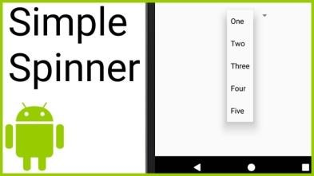

In android, Radio Button is a two-states button that can be either checked or unchecked and it’s the same as Checkbox control, except that it will allow only one option to select from the group of options. The user can press or click on the radio button to make it select. In android, Checkbox control allow users to change the state of control either Checked or Unchecked but the radio button cannot be unchecked once it is checked. Generally, we can use Radio Button controls in an android application to allow users to select only one option



from the set of values. Following is the pictorial representation of using Radio Button control in android applications.
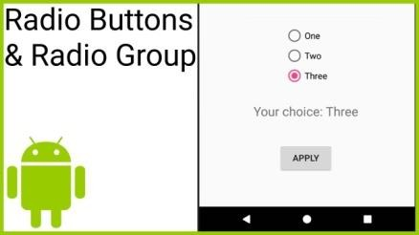

In android, Checkbox is a two-state button that can be either checked (ON) or unchecked (OFF) and it will allow users to toggle between the two states (ON / OFF) based on the requirements. Generally, we can use multiple Checkbox controls in android application to allow users to select one or more options from the set of values.
Following is the pictorial representation of using Checkbox control in android applications.
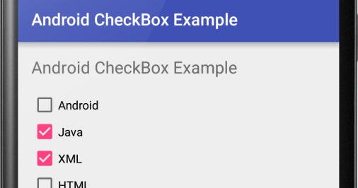

Here are the general steps to create registration form in Android Studio:

- First, we create a new project and add an empty activity.
- We use Constraint Layout for this sample, check for all the constraints after you finish.
- Add simple spinner for subject.
- Add radio button for gender.
- Add check box for qualification.
- After inserting the value and then show the data in show activity.



Code:
- MainActivity.java
package com.example.myregistrationapp;

import android.os.Bundle;
import android.view.View;
import android.widget.ArrayAdapter;
import android.widget.Button;
import android.widget.CheckBox;
import android.widget.EditText;
import android.widget.RadioButton;
import android.widget.RadioGroup;
import android.widget.Spinner;
import android.widget.TextView;
import android.widget.Toast;
import androidx.appcompat.app.AppCompatActivity;
import java.util.ArrayList;
public class MainActivity extends AppCompatActivity {
// 1. Declare variables for UI components
EditText etName;
Spinner spinnerBranch;
RadioGroup radioGroupGender;
CheckBox cbCricket, cbFootball, cbTennis;
Button btnSubmit;
TextView tvSummary;
@Override
protected void onCreate(Bundle savedInstanceState) {
super.onCreate(savedInstanceState);
setContentView(R.layout.activity_main);
// 2. Initialize Views (Connect Java variables to XML IDs)
etName = findViewById(R.id.etName);
spinnerBranch = findViewById(R.id.spinnerBranch);
radioGroupGender = findViewById(R.id.radioGroupGender);
cbCricket = findViewById(R.id.cbCricket);
cbFootball = findViewById(R.id.cbFootball);
cbTennis = findViewById(R.id.cbTennis);
btnSubmit = findViewById(R.id.btnSubmit);

tvSummary = findViewById(R.id.tvSummary);
// 3. Setup the Spinner with Branch Data
String[] branches = {"CSE", "E&TC", "IT", "AI_DS", "EC"};
ArrayAdapter<String> adapter = new ArrayAdapter<>(this,
android.R.layout.simple_spinner_dropdown_item, branches);
spinnerBranch.setAdapter(adapter);
// 4. Handle Button Click
btnSubmit.setOnClickListener(new View.OnClickListener() {
@Override
public void onClick(View v) {
generateSummary();
}
});
}
private void generateSummary() {
// Get Name
String name = etName.getText().toString();
// Get Branch
String branch = spinnerBranch.getSelectedItem().toString();
// Get Gender
String gender = "";
int selectedId = radioGroupGender.getCheckedRadioButtonId();



if (selectedId != -1) {
RadioButton selectedRb = findViewById(selectedId);
gender = selectedRb.getText().toString();
} else {
Toast.makeText(this, "Please select a gender", Toast.LENGTH_SHORT).show();
return; // Stop if no gender selected
}
// Get Sports (Checkboxes)
ArrayList<String> sportsList = new ArrayList<>();
if (cbCricket.isChecked()) sportsList.add("Cricket");
if (cbFootball.isChecked()) sportsList.add("Football");
if (cbTennis.isChecked()) sportsList.add("Tennis");
String sports = sportsList.toString().replace("[", "").replace("]", "");
if (sports.isEmpty()) sports = "None";
// Display Summary
String result = "REGISTRATION SUMMARY:\n" +
"---------------------\n" +"Name: " + name + "\n" +
"Branch: " + branch + "\n" +
"Gender: " + gender + "\n" +
"Sports: " + sports;
tvSummary.setText(result);
}
}

- activity_main.java
<?xml version="1.0" encoding="utf-8"?>
<ScrollView xmlns:android="http://schemas.android.com/apk/res/android"
android:layout_width="match_parent"
android:layout_height="match_parent"
android:background="#FFC0CB"
android:padding="16dp">
<LinearLayout
android:layout_width="match_parent"
android:layout_height="wrap_content"
android:orientation="vertical">
<TextView
android:layout_width="match_parent"
android:layout_height="29dp"
android:layout_marginBottom="20dp"
android:background="@color/white"
android:gravity="center"
android:text="Student Registration"
android:textColor="#000000"
android:textSize="24sp"
android:textStyle="bold" />
<EditText
android:id="@+id/etName"
android:layout_width="match_parent"
android:layout_height="wrap_content"
android:hint="Enter your name"
android:inputType="textPersonName"
android:minHeight="48dp"/>
<TextView
android:layout_width="wrap_content"
android:layout_height="wrap_content"
android:text="Select Branch:"
android:textSize="16sp"
android:layout_marginTop="10dp"/>
<Spinner
android:id="@+id/spinnerBranch"
android:layout_width="match_parent"



android:layout_height="48dp"
android:layout_marginBottom="10dp"/>
<TextView
android:layout_width="wrap_content"
android:layout_height="wrap_content"
android:text="Select Gender:"
android:textSize="16sp"
android:layout_marginTop="10dp"/>
<RadioGroup
android:id="@+id/radioGroupGender"
android:layout_width="match_parent"
android:layout_height="wrap_content"
android:orientation="horizontal">
<RadioButton
android:id="@+id/rbMale"
android:layout_width="wrap_content"
android:layout_height="wrap_content"
android:text="Male"/>
<RadioButton
android:id="@+id/rbFemale"
android:layout_width="wrap_content"
android:layout_height="wrap_content"
android:text="Female"/>
</RadioGroup>
<TextView
android:layout_width="wrap_content"
android:layout_height="wrap_content"
android:text="Interested Sports:"
android:textSize="16sp"
android:layout_marginTop="10dp"/>
<CheckBox
android:id="@+id/cbCricket"
android:layout_width="wrap_content"
android:layout_height="wrap_content"
android:text="Cricket"/>
<CheckBox
android:id="@+id/cbFootball"
android:layout_width="wrap_content"
android:layout_height="wrap_content"
android:text="Football"/>
<CheckBox
android:id="@+id/cbTennis"
android:layout_width="wrap_content"
android:layout_height="wrap_content"
android:text="Tennis"/>
<Button
android:id="@+id/btnSubmit"
android:layout_width="match_parent"
android:layout_height="wrap_content"
android:text="Submit"
android:layout_marginTop="20dp"/>
<TextView
android:id="@+id/tvSummary"
android:layout_width="match_parent"
android:layout_height="wrap_content"
android:textSize="18sp"
android:layout_marginTop="20dp"
android:textColor="#000000"
android:background="#FFFFFF"
android:padding="10dp"/>
</LinearLayout>
</ScrollView>


Output:

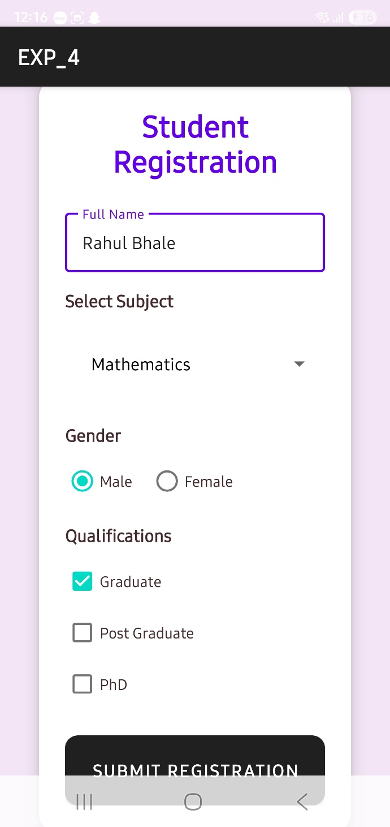 | 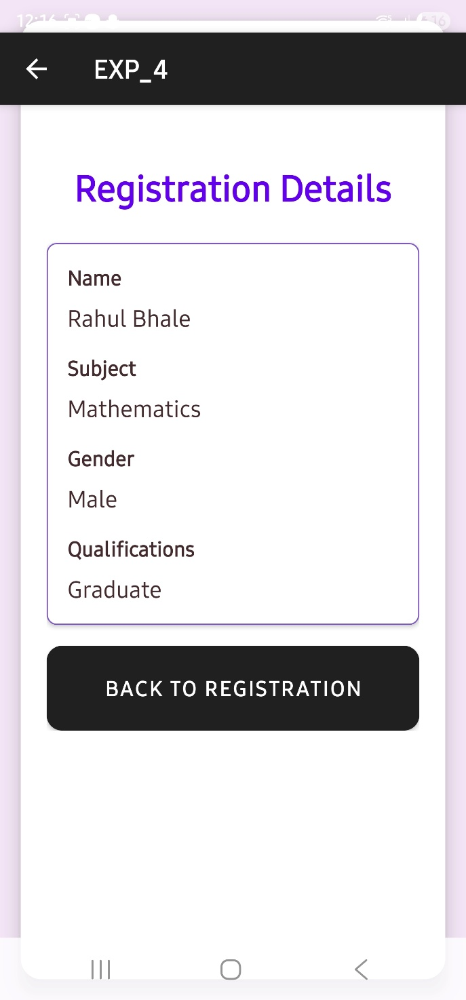

CONCLUSION:

……………………………………………………………………………………………

……………………………………………………………………………………………

……………………………………………………………………………………………



